DTEC502 – Database Design

Practical Assessment – SQL Test

Logan Findlater – 99117655

1)

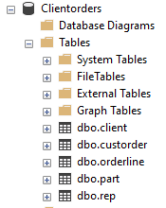

2)

SELECT firstname, lastname, city

FROM client

WHERE city = 'Dunedin';

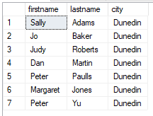

3)

SELECT firstname, lastname

FROM client

WHERE lastname LIKE 'J%';

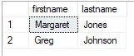

4)

SELECT firstname, lastname, balance

FROM client

WHERE balance > 50 AND balance < 150;

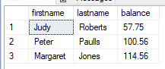

5)

SELECT firstname, lastname, city

FROM client

WHERE firstname = 'Mary' AND lastname = 'Nelson';



6)

SELECT firstname, lastname, balance, city

FROM client

WHERE balance < 200 AND city = 'Dunedin';

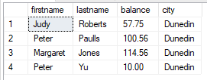

7)

SELECT custref, creditlimit, balance, (creditlimit - balance) AS NewBalance

FROM client;

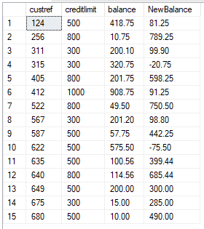

8)

SELECT orderref, partref, quantity, quotedPrice, (quantity \* quotedPrice) AS LineTotal

FROM orderline;

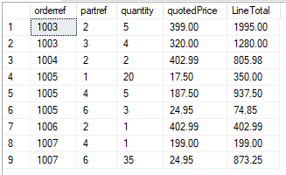

9)

SELECT custorder.orderref, custorder.orderdate

FROM custorder

INNER JOIN client ON custorder.custref=client.custref

WHERE custorder.orderdate > '1999-06-01';

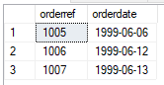

10)

SELECT city, COUNT(city) AS NumOfClients

FROM client

GROUP BY city

HAVING COUNT(city) > 3;



11)

SELECT rep.RepFirstname, rep.RepLastName, SUM((orderline.quantity \* orderline.quotedPrice) \* (rep.commission / 100)) AS RepBalance

FROM rep

INNER JOIN client ON rep.repref=client.repref

INNER JOIN custorder ON client.custref=custorder.custref

INNER JOIN orderline ON custorder.orderref=orderline.orderref

GROUP BY rep.RepFirstname, rep.RepLastName;

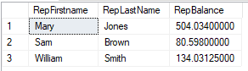

12)

SELECT city, SUM(balance) AS MaxBalance

FROM client

GROUP BY city;

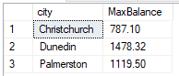

13)

SELECT CONCAT(client.firstname, ' ', client.lastname) AS CustName, CONCAT(rep.RepFirstName, ' ', rep.RepLastName) AS RepName

FROM client

INNER JOIN rep ON client.repref=rep.repref;

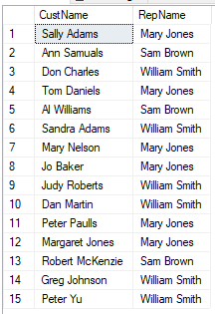

14)

SELECT custorder.orderref, custorder.orderdate, client.firstname, client.lastname

FROM custorder

INNER JOIN client ON custorder.custref=client.custref;

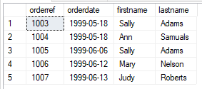

15)

SELECT orderline.orderref, part.description, part.onHand

FROM orderline

INNER JOIN part ON orderline.partref=part.partref

WHERE orderline.orderref = 1007;

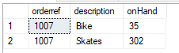

16)

SELECT orderline.orderref, part.description, orderline.quotedPrice, orderline.quantity

FROM orderline

INNER JOIN part ON orderline.partref=part.partref

ORDER BY part.description;

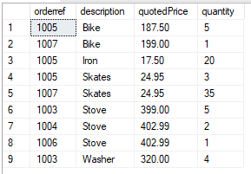

17)

SELECT orderline.orderref, part.description, orderline.quotedPrice, orderline.quantity

FROM orderline

INNER JOIN part ON orderline.partref=part.partref

WHERE orderline.quotedPrice > 200;

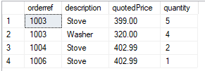

18)

SELECT custorder.orderref, custorder.orderdate, CONCAT(client.firstname, ' ', client.lastname) AS ClientName, part.description, part.unitPrice

FROM orderline

INNER JOIN custorder ON orderline.orderref=custorder.orderref

INNER JOIN client ON custorder.custref=client.custref

INNER JOIN part ON orderline.partref=part.partref;

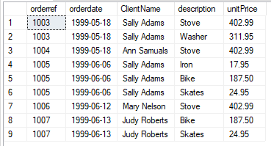

19)

SELECT custorder.orderref, custorder.orderdate, CONCAT(client.firstname, ' ', client.lastname) AS ClientName, part.description, part.unitPrice

FROM orderline

INNER JOIN custorder ON orderline.orderref=custorder.orderref

INNER JOIN client ON custorder.custref=client.custref

INNER JOIN part ON orderline.partref=part.partref

WHERE custorder.orderdate > '1999-06-10';

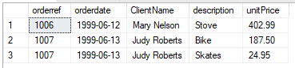

20)

SELECT custorder.orderref, custorder.orderdate, CONCAT(client.firstname, ' ', client.lastname) AS ClientName, CONCAT(rep.RepFirstname, ' ', rep.RepLastName) AS RepName, part.description

FROM orderline

INNER JOIN custorder ON orderline.orderref=custorder.orderref

INNER JOIN client ON custorder.custref=client.custref

INNER JOIN part ON orderline.partref=part.partref

INNER JOIN rep ON client.repref=rep.repref;

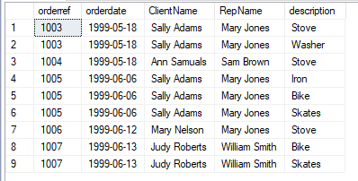

21)

SELECT CONCAT(rep.RepFirstname, ' ', rep.RepLastName) AS RepName, SUM(orderline.quantity \* orderline.quotedPrice) AS TotalBalance

FROM rep

INNER JOIN client ON rep.repref=client.repref

INNER JOIN custorder ON client.custref=custorder.custref

INNER JOIN orderline ON custorder.orderref=orderline.orderref

GROUP BY rep.RepFirstname, rep.RepLastName;

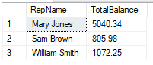

22)

SELECT orderref, SUM(quantity \* quotedPrice) AS LineTotal

FROM orderline

GROUP BY orderref;

